Community Membership Form

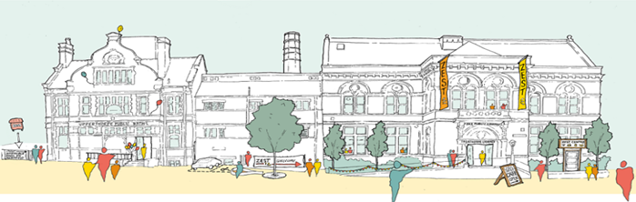

- Have a voice
- Be a part of the future
- Join us today

Friends of Zest

Zest* is an independent charity managed by a Trust Board elected from a local membership made up of local residents, community organisations and service users (including volunteers). Zest is here to support and strengthen the local community of Netherthorpe, Upperthorpe, Philadelphia and Langsett.

Friends of Zest We don’t ask for much but do ask you commit to:

- attend at least 2 quarterly social gatherings with guest speakers and activities to help share ideas about the community
- attend Zest Annual General Meeting at which you have a vote

In return Zest offers Friends:

- Great social opportunities and an annual Friends’ event
- A voice in shaping Zest’s future and chance to make a difference
- 10% discount on Pool and Gym Membership
- Voting rights at Zest’s Annual General Meeting
- Updates on activities and opportunities at Zest

Friends of Zest is open to individuals, or community groups who are interested in promoting the objects of the Charity and who are:

- Living or working in the Netherthorpe, Upperthorpe or Langsett areas of Sheffield; or
- Using Zest Charity services

To become a Friend of Zest just complete this form and hand it in Zest Centre Reception, email it to friends@zestcommunity.co.uk or post to Friends of Zest, Zest Centre, 18 Upperthorpe, S6 3NA.

Membership Form Part A

Are you applying as a (please select one with an x)

Local organisation / group
Local resident
Zest service user

If applying as a local organisation/ group please provide the name of the group and brief description:

If applying as a service user, which services/ groups do you currently use/ participate in?

Membership Form Part B

Title | Mr |  | Mrs |  | Miss |  | Ms.

Name

Address
Address | Post Code

Email
Contact no

Signed **

Date

Proof of ID

Please submit [paper or electronic] copy proof of address/ photo ID in the form of a passport or drivers licence and a utility bill that is less than 3 months old.

*Zest is the trading name of Netherthorpe and Upperthorpe Community Alliance.
Charity no: 1077083, Company no: 3628231.

**typed electronic signature accepted

Mailing List Subscription

I agree to my personal data being stored and used to receive Friends of Zest invitations and updates.

Yes |  | No

I agree to receive information and offers about Zest services, e.g. leisure service offers, health, work and youth service updates

Yes |  | No

You can change your mind at any time by emailing friends@zestcommunity.co.uk and stating Zest Mailing List Cancellation in the title.

GDPR
The information on this form is confidential, where we ask you to provide us with any information by which you can be identified, you can be assured that it will only be used in line with the General Data Protection Regulation (GDPR) 2018. We take your privacy seriously and are committed to protecting your personal information.

We will process your information in accordance with our Privacy Policy https://www.zestcommunity.co.uk/privacy-policy/

Enabling everyone in our community to lead successful, healthy lives

_______________________________________________

For office use only:

Copy I.D. provided? Yes/ No
Membership ratified by Board? Date
Membership start Date
Membership pack sent? Yes/ No
Added to mailing list? Yes/ No

Membership I.D. no: No.

