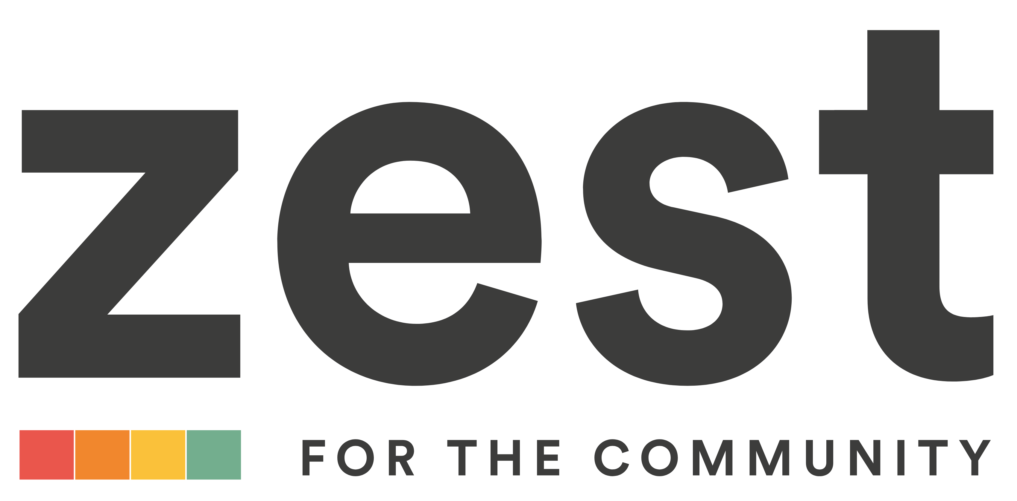

Dads Peer Support Facilitator

Post Title Dads Peer Support Facilitator
Location Zest
Rate of Pay £26000-27000 (pro-rata) dependent on experience
Hours 22.5 hours per week
Holidays 25 days per annum (pro rata)
Term Until 31st May 2026. Continuation subject to funding
Responsible to Community Services Manager

Are you a Dad and a great listener/communicator who wants to support other new Dads/Co-parents? Do you want to take a difference to families across the city? Be part of a caring, fun and passionate team who strive to help our families and communities.

Purpose of Job

To provide a range of activities for new or expectant Dads/Co-parents which provide peer support and guidance through mild mental health journeys. To recruit and train peer support volunteers.

Responsibilities

- To create open, inclusive, non-judgmental sessions which encourage Dads and Co-parents to talk freely about their mental health.
- To recruit, support, and motivate volunteers and their work.
- To promote the service citywide, ensuring strong referral pathways into the service.
- To organise a series of workshops, helpful to perinatal Dads/Co-Parents
- To organise events to celebrate volunteer achievements.
- To coordinate resources, including the reimbursement of expenses.
- To ensure precise records are retained detailing all work carried out by volunteers.
- To support volunteering to a high standard within the organisation and in line with the Sheffield Volunteering Standard.
- To participate in steering group meetings with other perinatal mental health services in Sheffield
- To promote services and opportunities, including updating the website and social media
- To keep up to date with legislation and policy relating to volunteering and to make any necessary modifications to working methods to accommodate changes.
- To complete reports and monitoring.
- To maintain databases and undertake any necessary administrative duties.
- To undertake any other duties as agreed with the Manager.
- To ensure the service works towards best practice in equality of opportunity.
- To undertake training and other development activity in line with organisational and personal development needs.
- To carry out all duties and responsibilities as described in line with ZEST policies and procedures, with particular attention to those relating to Equal Opportunities, Health and Safety and Data Protection.

Peer Support Facilitator
Person Specification

ESSENTIAL
Skills, Knowledge and Experience
- You must be male and a parent to fulfil this role
- At least 2 years’ experience of working with parents, families or children
- Knowledge and understanding of issues affecting children and families including parenting, health and child development.
- Experience managing volunteers
- Knowledge of using activity to help mental health
- Experience of organising events, sessions or workshops
- Knowledge and understanding of safeguarding.

Abilities
- Outstanding communication skills, both written and verbal
- Great interpersonal skills and approachability
- Strong organisational and administrative skills.
- Good IT skills including Word, Outlook and databases.
- Self-motivated and able to work on own initiative or as part of a team.

Circumstances
- Willingness to work flexible hours including evenings and weekends
- Full driving licence and own transport
- An enhanced DBS check will be required for this post.

DESIRABLE

- Experience of working or volunteering in a community environment.
- Experience in a similar role

To apply for the role, please submit your application form to HR@zestcommunity.co.uk by 9am on Monday 23rd June

For more details including application form, please visit Working for Us - ZestZest (zestcommunity.co.uk)

