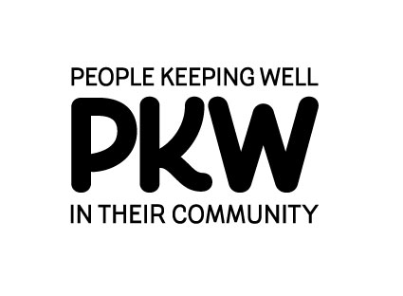
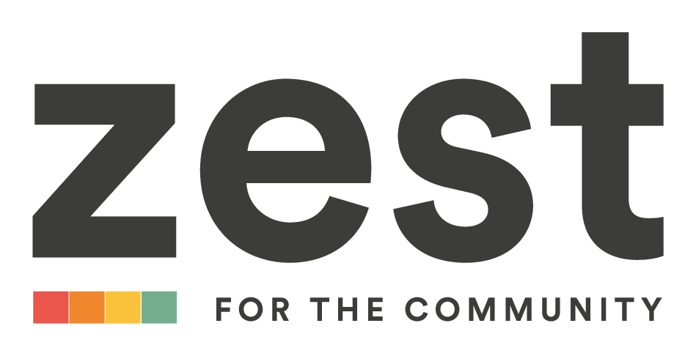

People Keeping Well (PKW)
Community Partnership

Small Grants and Dementia Small Grants Fund 2020_21

Zest is the Lead Body for the People Keeping Well (PKW) Community Partnership for:
- Netherthorpe, Upperthorpe, Langsett and Walkley.
- Middlewood, Wadsley, Hillsborough, Walkley Bank, Wisewood and Woodland (usually referred to as the Hillsborough Partnership).
- Crookes, Broomhill, Stannington, Crosspool and Lodge Moor (usually referred to as the West care Partnership).

We are pleased to announce that applications for Small Grants and Dementia Small Grants are invited from local groups for activities in the local areas listed above, which meet one or more of the 5 Ways to Wellbeing:

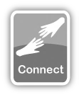 | Connect: connect with the people around you: your family, friends, colleagues and neighbours.
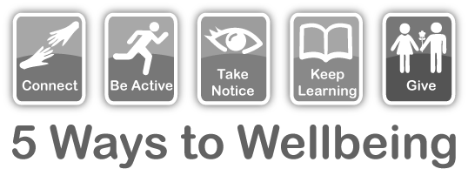 | Be active: Do what you can to be physically active.
 | Take Notice: Remember the simple things that give joy, be mindful of the things around you.
 | Keep learning: learning new skills can give you a sense of achievement and a new confidence.
 | Give: give your time to others, through volunteering.

Closing Date for Applications: 11:59pm, Sunday 17 Jan 2021.

Grant Size and Nature:

- You can apply for amounts up to £750 for your group.
- Your application may include costs of equipment and resources to help ensure group activities are Covid safe.
- The Dementia small grants are for activities that support people living with dementia and their carers. These specific grants can cover the following:
  - Making an existing group dementia friendly
  - Providing a dementia specific activity
  - Provide equipment to assist with a dementia activity
  - Renew an existing dementia activity

Eligibility

- Projects must be for the benefit of residents within:
  - Netherthorpe, Upperthorpe, Langsett, Walkley OR
  - Middlewood, Wadsley, Hillsborough, Walkley Bank, Wisewood, Woodland OR
  - Crookes, Broomhill, Stannington, Crosspool, Lodge Moor
- If you are a local group (but not a constituted group) ZEST (or another nominated organisation) can hold any awarded funds for you, which you can then access for your group.
- If you applied for (and were successful) in receiving a small grant from last year’s fund then your application can only be considered if ZEST received an end-of-project evaluation form from you.
- The fund is for groups only (not individuals).
- Projects funded via the dementia small grants must commit to attending a 2 hour Bronze Dementia Stars Training session before they can apply for future funds. (Zest will send successful applicants details of available courses)

Applying:
- Complete the following form and return it to health@zestcommunity.co.uk
by 17th January 2021.
Any Questions?
- If you’d like to have a talk about your idea before you apply, or want any advice then do feel free to email leaving your phone number and someone from the Health Team will call you back.

People Keeping Well (PKW)
Community Partnership

Small Grants Fund 2020_21

1.Contact details
Name of group or organisation applying:

Contact Name:
Address:
Email:
Telephone

Your Group
Is your group constituted?
(Does it have a governing document, clear purposes and its own bank account).
If not, will another group manage the project costs on your behalf? If so, who?
Location of your group (please indicate) | Netherthorpe / Upperthorpe / Langsett / Walkley | Y/N
Location of your group (please indicate) | Middlewood / Wadsley /Hillsborough/ Walkley Bank / Wisewood / Woodland | Y/N
Location of your group (please indicate) | Crookes/ Broomhill/ Lodge Moor/Stannington/Crosspool | Y/N
Are you applying for the Dementia Small Grants Pot? |  | Y/N

- About your Project
  - What do you plan to do?

Tell us about your project/activity. What is the activity this grant will support? Is it a new or continued activity? If you are applying for resources to make this activity Covid safe how will these enable you to run your activity safely?

  - Who will be involved in this project/activity?

E.g. older people. If your activity involves vulnerable people, children or young people, DBS checks will need to be carried out.

  - Where will your activity take place?

  - What do you hope to achieve with this project/activity?

What difference do you hope to make? How many people will benefit from this project/activity?

  - How will you make this activity Covid safe?
  - Which of the 5 Ways to Wellbeing does this project support and how?

  - When will the project start?
The project needs to have started by mid-March 2021.
  - Does the project have an end date? If so when?

- Project Costs
How much money do you need and what will you spend it on?
Please list and price where possible each item.
Please also show that planned activities are covered by insurance, either by the host organisation or included in the costs below.
Item | Price per item | Total Cost (£)
Total

Bank details
Please provide bank details of your group or host organisation.

Bank:

Account Name:

Account Number:

Sort Code:

Note. Please do not pay out (or agree to pay) anything related to your project until you have been informed in writing that your application has been approved.
- Evaluation
  - How will you know your project has been successful?

What are you going to collect to show/evidence this (e.g. attendance figures, case studies)?

If for Covid support resources how will these benefit the project?

- Future Plans
  - Do you have plans to carry on the activity/project after the funding has finished?

- Declaration It is important that you understand and agree to sign the following statements. Please note that if you leave the group/organisation or can no longer fulfill your responsibilities, or someone else takes over responsibility for the investment on behalf of the group/organisation, you must inform us immediately.
- We are authorised to make the application on behalf of the above group/organisation.
- We certify that the information contained in this application is correct.

Name of person submitting form |  | Role in group
Signature |  | Date

Please send your completed Application Form by e-mail to health@zestcommunity.co.uk
or post to: PKW Small Grants, ZEST Centre, 18 Upperthorpe, Sheffield, S6 3NA

The intended timetable for the 2020- 21 Small Grants Programme is:
Stage in Small Grant Assessment -Process  Applications Close  Panel meeting week commencing  Applicants informed of outcome | Dates  11:59pm, Sunday 17 January 2021  08 Feb 2021  16 Feb 2021

